# Tax free returns on interest earned:

## For government employees

In both EPF+VPF combined, you can invest up to 5 lakhs and earn 8.1% interest rate (this is better than many other certificates and bonds that are available and has sovereign (government security) as of today.

## For private employees

In both EPF+VPF combined, you can invest up to 2.5 lakhs and earn 8.1% interest rate (this is better than many other certificates and bonds that are available and has sovereign (government security) as of today.

# Tax planning for salary

## LTA

Employees travelling on leaves, expenses made for travelling (for you, immediate siblings, your spouse and 2 children Inside India) can be claimed under LTA SECTION 10(5)

**Only travel related (air (economy travel), bus (up to deluxe), train (up to first class))**

### Limit for LTA

Maximum up to limit specified by your employer in CTC.

If your limit is 50,000, and you have spent 30,000 for LTA, then remaining 20,000 will join the taxable salary slab.

### Rules for LTA

Only shortest distance between source and destination is allowed.

LTA can be reimbursed only twice in a block period (a block period is a period of 4 years ex: 2018-2011, 2012-2015)

If you only use LTA once in a block year, you can carry forward remaining chance to next block year. (only one chance can be forwarded to next block year).

The remaining claim from previous block year, has to be claimed in the first year of current block year.

Can LTA be claimed only on leave days, or can also be claimed on weekends? 🡪 depends on the company that you work for.

If LTA is not in CTC, can we claim? 🡪 no.

LTA is there in tiger:

* 3 Flexi benefits include some tax-free components (Telephone/Wifi, Meal Vouchers, LTA)
* LTA can max be covered for 117000

## Section 80

### 80C

Can get exemption up to 1.5L under this section

#### Exemption without investing money

##### EPF

PF contributed from your salary

##### Home loan

Principal of home loan (not interest) can be claimed under this section.

##### Child education

Tuition fee of upto 2 children can be claimed.

#### Exemption with investing money

Order of priority should be ELSS, PPF, SSY

##### ELSS

This is best as it has flexibility

Less lock-in period

Also you can invest in different funds different years.

##### PPF

Amount invested in PPF can be claimed here

##### SSY

Amount deposited for girl child in this govt scheme can be availed as exemption

##### National Saving Certificate (NSC)

Can invest in NSC

##### Tax saving FD

FDs which have 5 year lock-in period

##### Insurance premium

Premiums such as term insurance and other traditional insurances can be claimed under this section

##### ULIPS

### 80D

Preventive health check-ups can also come under this section.

Premium paid for health insurance can be claimed under this section.

* If you are taking health insurance for your parents, make yourself proposer so that, you can claim your parent’s health insurance under this section.

Any premium payment that you do, should not be in cash mode (can be any other payment mode).

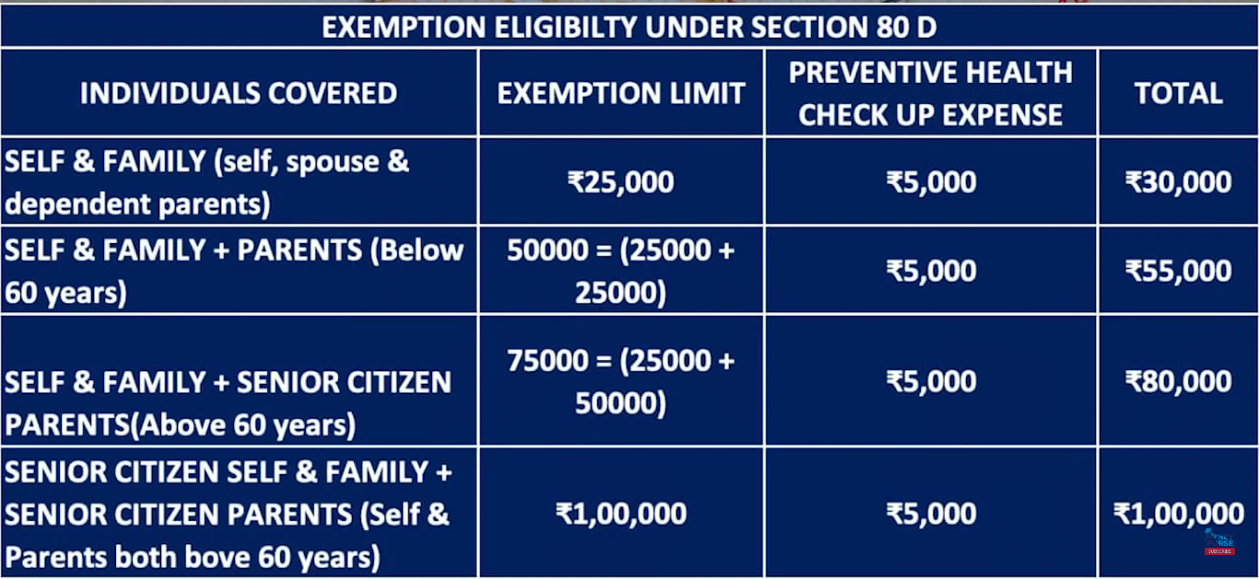

### 80CCD1B

Can avail exemption by investing in NPS upto 50,000

### 80EEA

Can avail exemption up to 150000 on top of 24B for interest on home loan, but

* Home that you are buying should be first residential house.
* Stamp duty of the house should be less than 45 lakhs
* House should be bought between 1st April 2019 to 31st march 2021

### 80EEB

On electric car bought, interest on loan can be exempted up to 1.5L

Car should be bought between 1st April 2019 – 31st march 2023

### 80G

If you donate to organizations which provide Donation Receipts for availing the tax benefits u/s 80G of the Income-tax Act. You can claim the exemption here.

## 24B

Home loan- can avail exemption upto 2 lakhs on home loan.